2020 Tournament Dedication

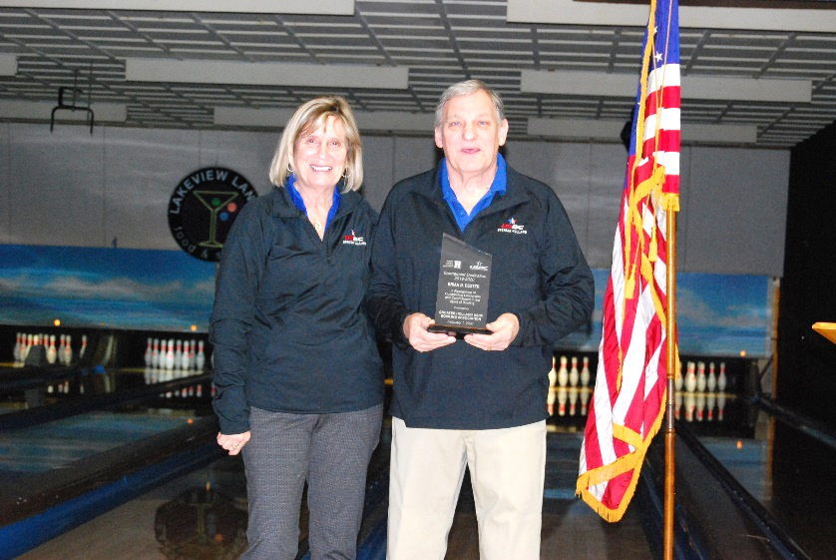
Brian Dexter

Brian started bowling as a teen in Hastings and it wasn't long before he was bowling and working at Hastings Bowl.
When his wife Sue met Brain, he was working several nights a week at the bowling alley and bowling in six leagues too. I guess you could say he loved the game!
He has bowled in 36 National Tournaments and at least that many State Tournaments too. And more than that in City Tournaments as well. He has helped junior bowlers including our own two sons, Barry and Ryan.
He and Ryan still bowl together on Tuesday nights at Northland Lanes.
President DeBoer Presenting Brian with his plaque

He has had eight 300 games, including the first from our association to have one at the National tournament. His high series is an 803.
For many years trips to National Tournaments were vacations every year for Sue and Brain. Lots of fun great memories.

Brain has served on the Greater Holland Bowling Association board since 1992, for 28 years.
He has been on several committees, including Awards, Finance, and Legislative.
He has also served many times as a Holland representative at state meetings.
He also bowls in and supports the GHBA other tournaments, including: Tulip City Mixed Doubles, the Holiday tournament and has even bowled in the Family tournament. Brian loves the game of bowling, and the people he has met and bowled with over the years.

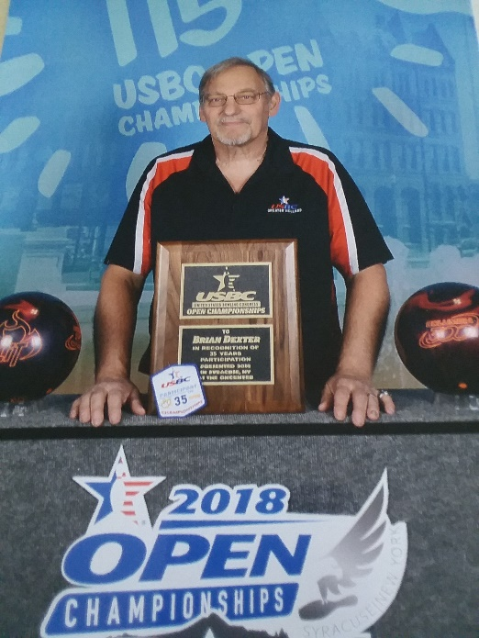
Brian, pictured here, completed 35 years in bowling in the national
Tournament in 2018.

The Greater Holland Bowling Association is proud to dedicate this tournament to Brian for his many years of service to bowling,

