The 2015 City tournament was dedicated to Cindy Whittecar
for her contributions to the sport of bowling.
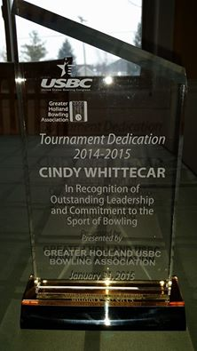
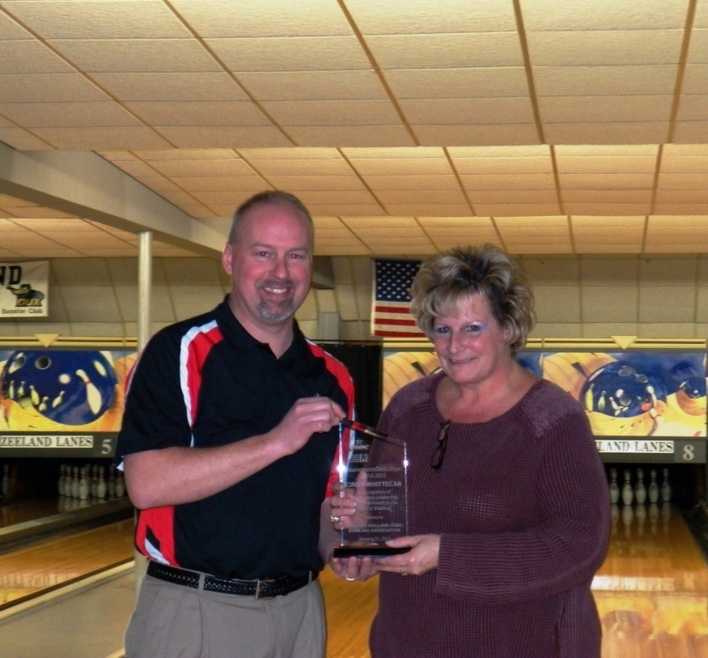

President Tod Grams presents Cindy with her plaque at the opening ceremonies – GHBA City Tournament-Zeeland Lanes

Cindy has been involved in many facets of the bowling world, since her dad, Hub purchased the Zeeland lanes in 1981. She has worked “behind the scenes”; learning the art of oiling the lanes, cleaning up at the center, and working at the counter, all to service area bowlers.
She has been secretary of a men’s league that bowls at Zeeland lanes, for 20 plus years.

She has been secretary/coach for the junior’s leagues for over 25 years. She loves working with the kids and especially enjoys doing one on one coaching with them. Cindy stated, “That even though Zeeland Lanes is a small house, the talented kids that come out of here is amazing”
Even though she doesn’t have kids of her own, these are HER KIDS.

Cindy also bowls in the City tournament yearly, and has bowled in State and national Tournaments. She has been a member of the All City teams, and can claim that” perfect game”, rolled in 2007.

We honor Cindy with this tournament dedication, as a small THANK YOU for all the work she has done to support and to promote bowling in the Holland area.

